**08 – Tuple/Set**



**Department of Computer Science and Engineering | Rajalakshmi Engineering College**

**.**

**Ex. No.** **:** **8.1** **Date: 31.05.2024**

**Register No.:.: 231401056** **Name: LAKHSHUYAA SHRI B**



**Binary String**

**Coders here is a simple task for you, Given string str. Your task is to check whether it is a binary string or not by using python set.**

**Examples:**

**Input: str = "01010101010"**

**Output: Yes**

**Input: str = "REC101"**

**Output: No**

**For example:**



 **Input** **Result**



 **01010101010** **Yes**



 **010101 10101**  **No**

**a = input()**

**try:**

**c = int(a)**

**print("Yes")**

**except:**

**print("No")**



**Department of Computer Science and Engineering | Rajalakshmi Engineering College**

**.**

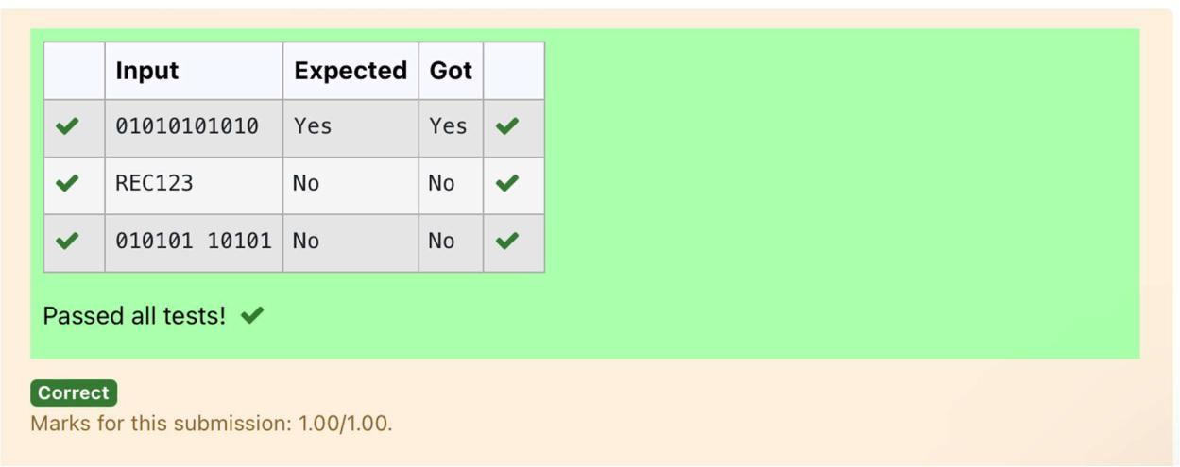

**Department of Computer Science and Engineering | Rajalakshmi Engineering College**

**.**



**Ex. No.** **:** **8.2** **Date: 31.05.2024**

**Register No.:.: 231401056** **Name: LAKHSHUYAA SHRI B**



**Check Pair**

**Given a tuple and a positive integer k, the task is to find the count of distinct pairs in the tuple whose sum is equal to K.**

**Examples:**

**Input: t = (5, 6, 5, 7, 7, 8 ), K = 13**

**Output: 2**

**Explanation:**

**Pairs with sum K( = 13) are {(5, 8), (6, 7), (6, 7)}.**

**Therefore, distinct pairs with sum K( = 13) are { (5, 8), (6, 7) }.**

**Therefore, the required output is 2.**

|  |  |
| --- | --- |
| **For example:** |  |
| **Input** | **Result** |
| **1,2,1,2,5** | **1** |
| **3** |  |
| **1,2** | **0** |
| **0** |  |

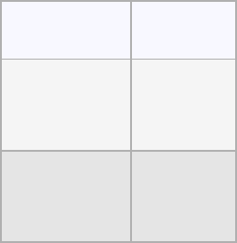

**t = input()**

**k = int(input())**

**a = t.split(",")**

**l = [int(x) for x in a]**

**count = 0**

**x = set()**

**for i in range(len(l)):**

**for j in range(i + 1, len(l)):**



**Department of Computer Science and Engineering | Rajalakshmi Engineering College**

**.**

**if l[i] + l[j] == k:**

**s = (l[i], l[j])**

**if s not in x and (l[j], l[i]) not in x:**

**count += 1**

**x.add(s)**

**print(count)**

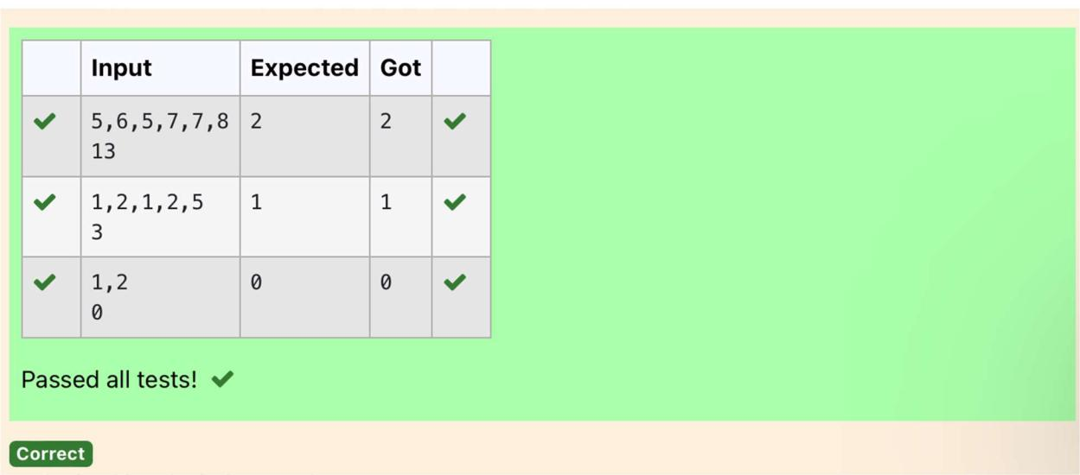

**Department of Computer Science and Engineering | Rajalakshmi Engineering College**

**.**

**Ex. No.** **:** **8.3** **Date: 31.05.2024**

**Register No.:.: 231401056** **Name: LAKHSHUYAA SHRI B**



**DNA Sequence**

**The DNA sequence is composed of a series of nucleotides abbreviated as 'A', 'C', 'G', and 'T'.**

**For example, "ACGAATTCCG" is a DNA sequence.**

**When studying DNA, it is useful to identify repeated sequences within the DNA.**

**Given a string s that represents a DNA sequence, return all the 10-letter-long sequences (substrings) that occur more than once in a DNA molecule. You may return the answer in any order.**

**Example 1:**

**Input: s = "AAAAACCCCCAAAAACCCCCCAAAAAGGGTTT"**

**Output: ["AAAAACCCCC","CCCCCAAAAA"]**

**Example 2:**

**Input: s = "AAAAAAAAAAAAA"**

**Output: ["AAAAAAAAAA"]**

**For example:**

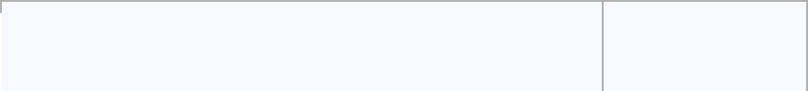

 **Input** **Result**

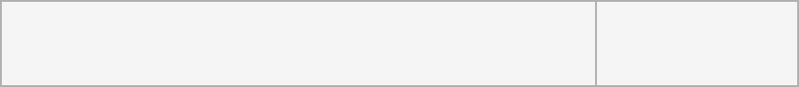

**AAAAACCCCCAAAAACCCCCCAAAAAGGGTTT AAAAACCCCC CCCCCAAAAA**

**s = input()**

**j = []**

**repeated = set()**

**for i in range(len(s) - 9):**

**sequence = s[i:i+10]**



**Department of Computer Science and Engineering | Rajalakshmi Engineering College**

**.**

**if sequence in j:**

**repeated.add(sequence)**

**else:**

**j.append(sequence)**

**l=list(repeated)**

**l=list(reversed(l))**

**for i in l:**

**print(i)**

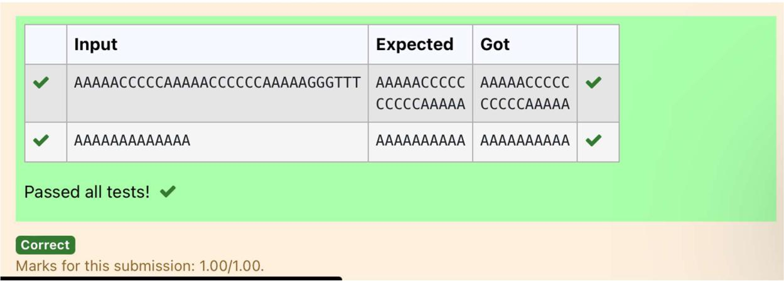

**Department of Computer Science and Engineering | Rajalakshmi Engineering College**

**.**

**Ex. No.** **:** **8.4** **Date: 31.05.2024**

**Register No.:.: 231401056** **Name: LAKHSHUYAA SHRI B**



**Print repeated no**

**Given an array of integers nums containing n + 1 integers where each integer is in the range [1, n] inclusive.There is only one repeated number in nums, return this repeated number. Solve the problem using set.**

**Example 1:**

**Input: nums = [1,3,4,2,2]**

**Output: 2**

**Example 2:**

**Input: nums = [3,1,3,4,2]**

**Output: 3**

**For example:**

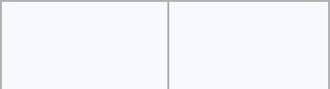

**Input** **Result**



**13442**  **4**

**n =input().split(" ")**

**n = list(n)**

**for i in range(len(n)):**

**for j in range(i+1,len(n)):**

**if n[i] == n[j]:**

**print(n[i])**

**exit(0)**



**Department of Computer Science and Engineering | Rajalakshmi Engineering College**

**.**

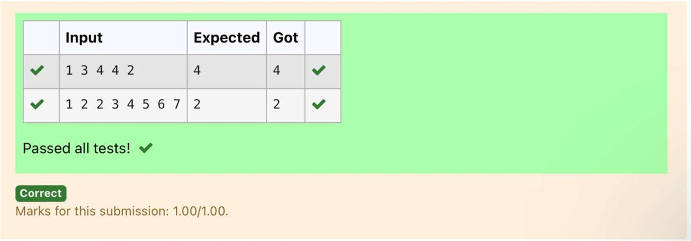

**Department of Computer Science and Engineering | Rajalakshmi Engineering College**

**.**



**Ex. No.** **:** **8.5** **Date: 31.05.2024**

**Register No.:.: 231401056** **Name: LAKHSHUYAA SHRI B**



**Remove repeated**

**Write a program to eliminate the common elements in the given 2 arrays and print only the non-repeating elements and the total number of such non-repeating elements.**

**Input Format:**

**The first line contains space-separated values, denoting the size of the two arrays in integer format respectively.**

**The next two lines contain the space-separated integer arrays to be compared.**

**Sample Input:**

**5 4**

**12865**

**26810**

**Sample Output:**

**1510**

**3**

**Sample Input:**

**5 5**

**12345**

**12345**

**Sample Output:**

**NO SUCH ELEMENTS**

**For example:**



**Department of Computer Science and Engineering | Rajalakshmi Engineering College**

**.**



|  |  |
| --- | --- |
| **Input** | **Result** |
| **5 4** | **1510** |
| **12865** | **3** |
| **26810** |  |

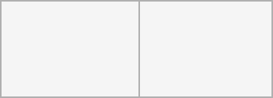

**a=input()**

**d=[]**

**b=input()**

**c=input()**

**b=tuple(b.split(" "))**

**c=tuple(c.split(" "))**

**for i in b:**

**if i not in c:**

**d.append(i)**

**for i in c:**

**if i not in b:**

**d.append(i)**

**for i in range(len(d)):**

**print(int(d[i]),end=' ')**

**print()**

**print(len(d))**



**Department of Computer Science and Engineering | Rajalakshmi Engineering College**

**.**

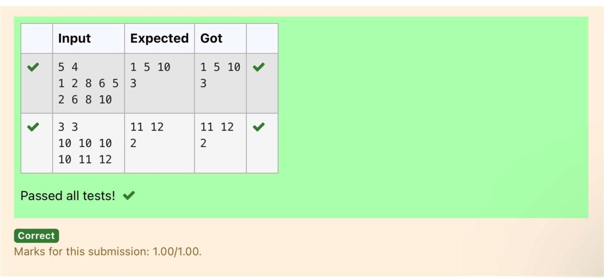

**Department of Computer Science and Engineering | Rajalakshmi Engineering College**

**.**



**Ex. No.** **:** **8.6** **Date: 31.05.2024**

**Register No.:.: 231401056** **Name: LAKHSHUYAA SHRI B**



**Malfunctioning Keyboard**

**There is a malfunctioning keyboard where some letter keys do not work. All other keys on the keyboard work properly.**

**Given a string text of words separated by a single space (no leading or trailing spaces) and a string brokenLetters of all distinct letter keys that are broken, return the number of words in text you can fully type using this keyboard.**

**Example 1:**

**Input: text = "hello world", brokenLetters = "ad"**

**Output:**

**1**

**Explanation: We cannot type "world" because the 'd' key is broken.**

**For example:**

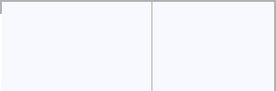

 **Input** **Result**

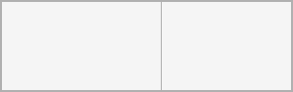

**hello world 1**

**ad**

**a=input()**

**b=input()**

**c=set()**

**for i in a:**

**for j in b:**

**if j in i:**

**c.add(i)**

**print(len(c))**



**Department of Computer Science and Engineering | Rajalakshmi Engineering College**

**.**

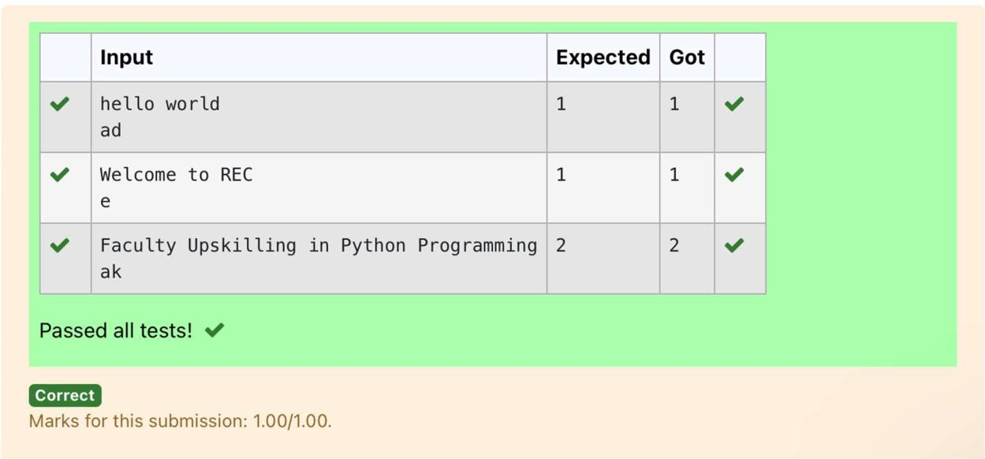

**Department of Computer Science and Engineering | Rajalakshmi Engineering College**

**.**



**Ex. No.** **:** **8.7** **Date: 31.05.2024**

**Register No.:.: 231401056** **Name: LAKHSHUYAA SHRI B**



**American keyboard**

**Given an array of strings words, return the words that can be typed using letters of the alphabet on only one row of American keyboard like the image below.**

**In the American keyboard:**

* **the first row consists of the characters "qwertyuiop",**
* **the second row consists of the characters "asdfghjkl", and**
* **the third row consists of the characters "zxcvbnm"**

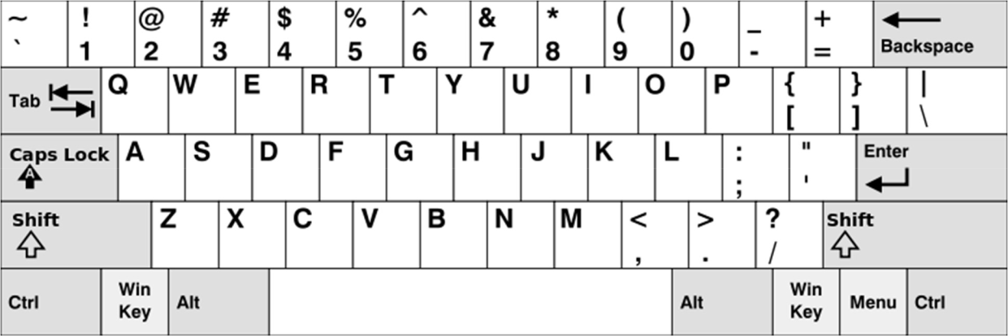

**Example 1:**

**Input: words = ["Hello","Alaska","Dad","Peace"]**

**Output: ["Alaska","Dad"]**

**Example 2:**

**Input: words = ["omk"]**

**Output: []**

**Example 3:**

**Input: words = ["adsdf","sfd"]**

**Output: ["adsdf","sfd"]**

**For example:**



**Department of Computer Science and Engineering | Rajalakshmi Engineering College**

**.**

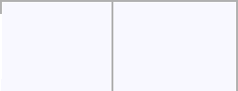

 **Input Result**

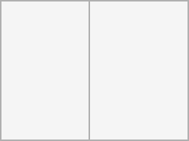

* **Alaska**

**Hello Dad Alaska**

**Dad Peace**

**def findWords(words):**

**row1 = set('qwertyuiop')**

**row2 = set('asdfghjkl')**

**row3 = set('zxcvbnm')**

**result = []**

**for word in words:**

**w = set(word.lower())**

**if w.issubset(row1) or w.issubset(row2) or w.issubset(row3):**

**result.append(word)**

**if len(result) == 0:**

**print("No words")**

**else:**

**for i in result:**

**print(i)**

**a = int(input())**

**arr = [input() for i in range(a)]**

**findWords(arr)**



**Department of Computer Science and Engineering | Rajalakshmi Engineering College**

**.**

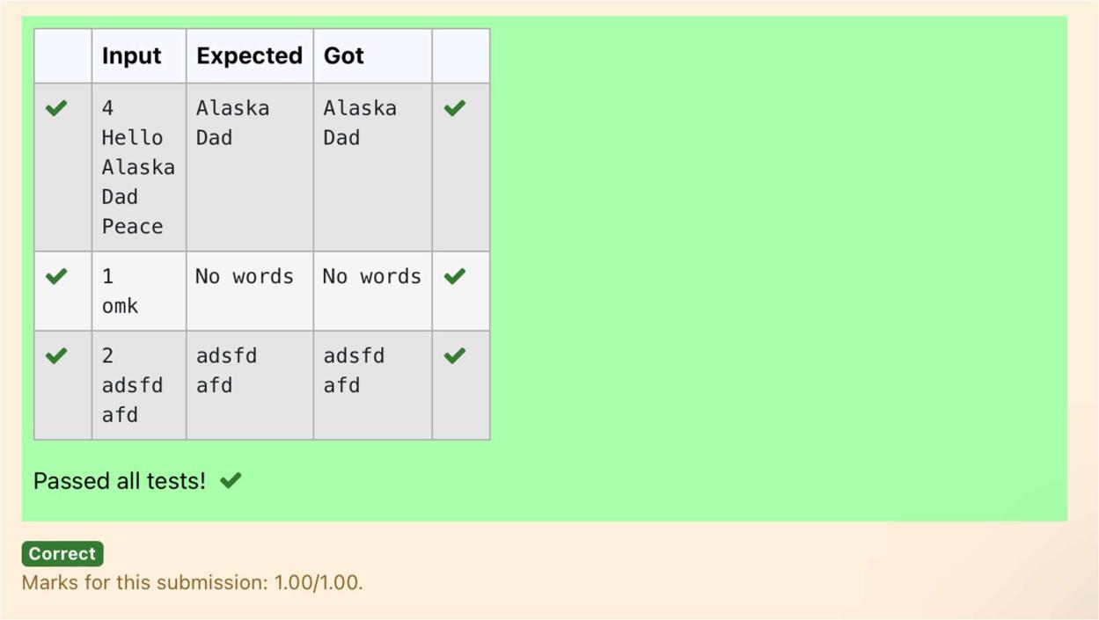

**Department of Computer Science and Engineering | Rajalakshmi Engineering College**

**.**

